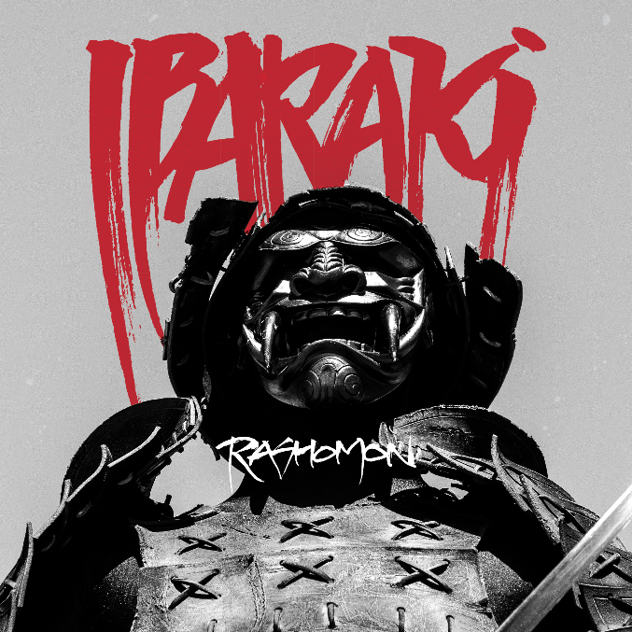

IBARAKI

»Rashomon«

OUT: May 6th 2022
Line up: | IBARAKI online:
Matt Heafy | Vocals, Guitar | https://twitter.com/ibarakiband  https://www.facebook.com/ibarakiband  https://www.instagram.com/ibarakiband  https://www.ibarakiband.com/
Say the name TRIVIUM and reverence follows. That’s because in the annals of modern metal there are few stories more illustrious or celebrated than the one that began with that group of impossibly young Floridian misfits dreaming of the lighted stage over 20 years ago. In the time since those heady days, their career has been burnished by the kind of triumphs wrought by the sweaty toil of relentless touring and the steady anvil-beat of landmark releases that have won them a legion of fans around the world. Just as TRIVIUM have tirelessly forged their careers, so too have those ceaseless hammer-blows shaped Matt Heafy who, with each passing year, has taken shape as an artist, songwriter and thrilling frontman on stage, and one of metal’s most compelling voices when he’s off.
Given the close intertwining of Matt and TRIVIUM’s stories, you’d have thought the two would be inseparable, but not so, because IBARAKI – the name for a terrifying Japanese demon taken from feudal legend – is more than a solo record. As he tells it, it’s the end-result of a journey to find his voice. It’s personal, it’s deep, and as he explains, its inspirations include everything from an adoration for the extremes of black metal, to the exuberant storytelling of Gerard Way, to the adventuresome worldliness of tragic bon viveur Anthony Bourdain. It’s a reflection of his multifaceted interests as well as a profound affirmation of his Japanese-American identity, and one that led him to confront one of his family’s most tragic moments. Like the artist behind it, there is much to the story of IBARAKI and it began with a timid email to one of black metal’s most revered and influential figures.
“Black metal was always big for me – before TRIVIUM I’d been in a band called MINDSCAR, and I’d been so drawn into that world – the lore of it all, where it came from: pagan cultures, the old gods. I loved it. We parted ways, TRIVIUM happened, and fast-forward to maybe 2009, and I said, ‘screw it, I want to make a black metal project.’ But I knew what metalheads would think. ‘Matt’s commercial, he knows nothing, he’s not allowed in.’ So I thought about making it under an alias and I wrote something and I sent it to Darren Toms from Candlelight Records who’d seen me in magazines wearing EMPEROR shirts. I said, ‘hey what do you think? Would you mind passing this onto Ihsahn?’ He was one of my heroes – I’d never met him. Then I get this email from Ihsahn and I don’t remember exactly what he said, but he was like, ‘good work’. It was so cool to get that nod and it inspired me to start checking some of his solo stuff. He’d just released his own solo record and I’d never heard anything like it – saxophones, clean singing, jazz chords. It was incredible to me. He’s this non-stop inventor. So I started writing in a totally different way.”
It was Matt’s exposure to Ihsahn’s solo work that would inspire the gradual craftsmanship that would eventually become IBARAKI. It was also the beginning of a friendship and creative collaboration that would eventually compel Ihsahn to take a leap of his own into a newfound role as producer on the project. While much of the material for IBARAKI was assembled over those months and years – as much a songwriting process as an exchange of ideas between friends – it wasn’t until the pandemic that the space was created and the idea could really flourish. “It was very loose,” says Ihsahn. “We just had rough demos for a very long time because we’re arguably pretty busy people, but suddenly everything was cancelled and we had time on our hands for the first time, so it was like, ‘OK, let’s do this.’ We never got to work in the same room; he’d track guitars and send them to me, I’d run them through my studio and send them back. It was a new way of working, but it was like he was there on the other side of the glass. Matt is a very, very positive energetic and passionate music fan – we have similar attitudes to music and open mindedness. We hit it off, and it’s been really rewarding to me. I’ve always been on the artist's side, but Matt made it so easy for me because there’s no ego and he’s so open to new perspectives and he isn’t afraid of changing directions. He has such a wide range of musical influences. We talked about that and it was very obvious for me that he could extend his talents to a wider range. In all extreme genres there’s always a very small stereotypical framework of what you're supposed to do.”
As Ihsahn further explains, the creative interactions between Matt and himself are down to a deep trust borne of a commonality in their stories that isn’t immediately obvious. “We both started our respective bands when we were 13,” he says. “We got signed when we were 16. That's young, and in essence we both found our path in life at an early age. We've talked a lot about that and our different experiences with that, because it’s like we know nothing else.”
But IBARAKI was more than just an expression of Matt and Ihsahn’s deep creative resonance. He got by with a little help from his friends, too. While primarily written by Matt, Ihsahn engineered and produced and contributed some song structures, plus TRIVIUM drummer Alex Bent and bassist Paolo Gregoletto and guitarist Corey Beaulieu contributed to various tracks. Ihsahn’s wife Heidi even sampled some natural sounds from the forest near their home and his entire family and Gerard Way contributed guest vocals to the song “Ronin”. “We got Nergal doing guest vocals on ‘Akumu’, too, which was just amazing,” says Matt .
As pivotal as Matt’s interactions with novice producer Ihsahn would be, it wasn’t just his perspective on music that was about to change. The shift that would imbue IBARAKI with its unique cultural identity – aside from its joyous musical eccentricities and creative sojourns which really have to be heard to be believed – but it’s the inspirational personal journey behind it that makes it a true standalone. That’s because just as Ihsahn encouraged Matt to break with the limiting musical conventions of the genre, he also motivated him to seek out new avenues for lyrical inspiration.
“We were on Facetime, and I mentioned that I wished I was Scandinavian,” says Matt. “I was like, ‘I'm so into the lore, I could write about Norwegian and Scandinavian histories. Ihsahn was like, ‘that's been done. You should really channel what you have, look at your own culture and go into that’. It was like, ‘oh yeah, I'm Japanese!’ So I should be writing about this vast, incredible array of stories that I already have tattooed on my body. I mean, every tattoo I have is a specific ancient Japanese story of gods, goddesses, and monsters from the Shinto religion that my mom taught me. As much as I wanted to be a Norwegian in a black metal band singing about Thor, what I should have been doing was right there in front of me. It was me. It changed everything, and I started pouring out these lyrics.”
More than an album simply inspired by Japanese mythology and folklore, to Matt, IBARAKI is – like so many things from the land of the rising sun – an album that exists on two levels. The imaginary and the literal. The layers of meaning also abound, as do demons both real and imagined.
“In Japan there’s this thing about karoshi, salarymen who work themselves to death. I don’t talk about this much, but my uncle Kiichi killed himself. His name is my middle name. He was a police officer in Japan, he had a family. I remember coming home to find my mother sobbing. I assume he lost his job. I tried to figure out why that is and it made me want to explore that. Japan has a high rate of suicide so on the surface it seems like it’s all happy, but it isn’t. I started talking to my mom about it and I recognised the same pressure and anxieties that I place on myself. People think a music career is this wonderland, but it really isn’t. I really wanted to explore that on this record too.”
So it wasn’t just the rich mythology and folklore of Japan that would give IBARAKI its unique aesthetics and influences – it would provide Matt with the catalyst to contemplate his own identity and to consider how recent tragedies stateside have highlighted the need for better representation in metal. The rise in anti-Asian violence and bigotry was something that Matt was keen to confront.
“The violence in America towards Asians, the murders of Asians because of people's small-mindedness – we can see what’s happening. It's like I never quite felt like I was Asian enough because I'm half and I never felt white enough because I'm half, but I feel like it's important for me to talk about this now. Everything has a rich, amazing, beautiful culture behind it – every single civilisation, every culture, every walk of life. So I hope that it can make Asian metalheads or Asian fans of music feel a little bit more represented. It’s great to be able to say, ‘this is where I'm from,’ and, ‘this is who I am.’”

